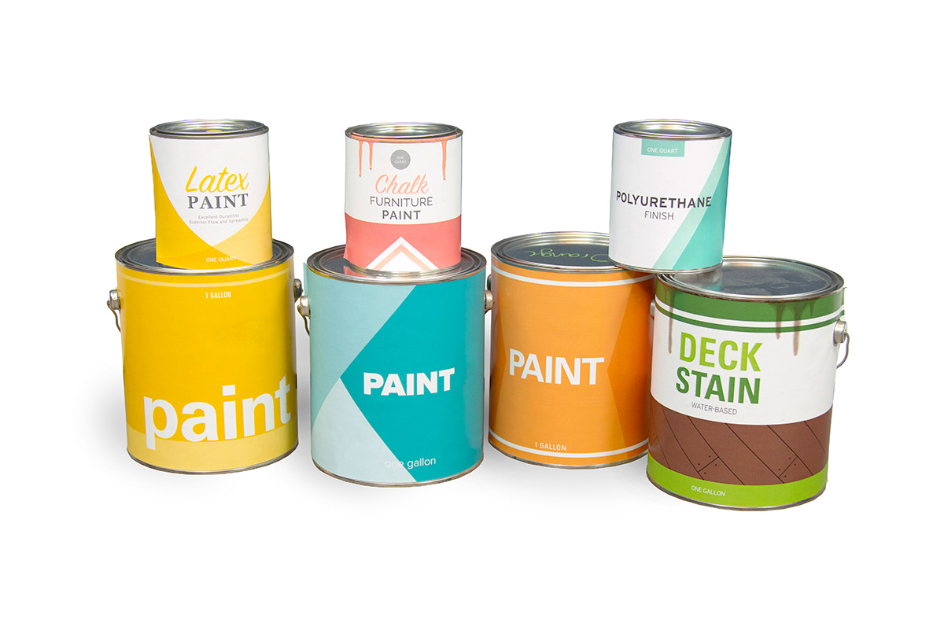

Got left over paint or stain from a home project?

Don’t place them in your Green or Blue barrels! Check out PaintCare and find out where you can get rid of them for free! <https://www.paintcare.org/paintcare-states/connecticut/#/everyone>